# Multi Material Upgrade 2 DIP Manual

# Specification

Multi Material Upgrade 2 DIP (MMU2 DIP) is a scalable upgrade to MMU2S, which enables MMU2S to support multiple driver models. At the same time, it replaces MCU with STM32F030, so it is no longer compatible with the original MMU2S firmware.

.

**1.1 MMU2 DIP Size Diagram**

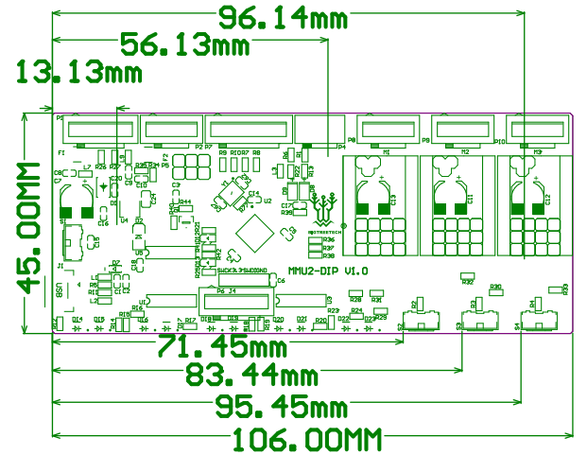

**1.2 MMU2DIP Wiring Diagram**

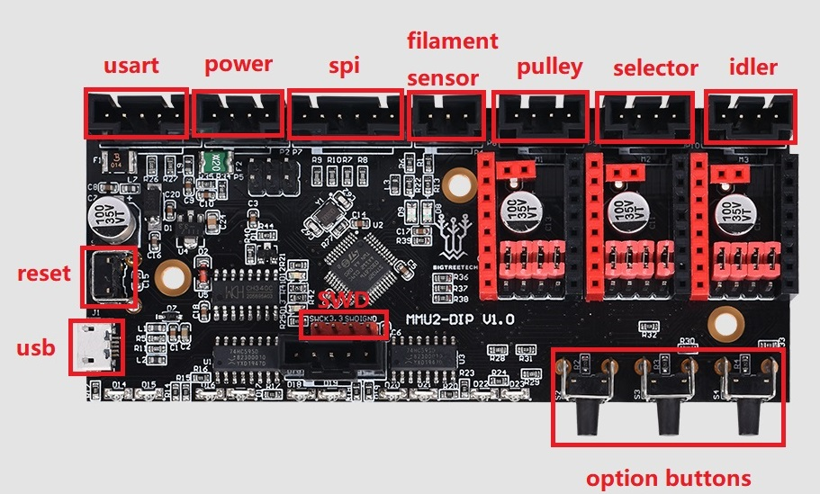

**1.3 MMU2DIP components name:**

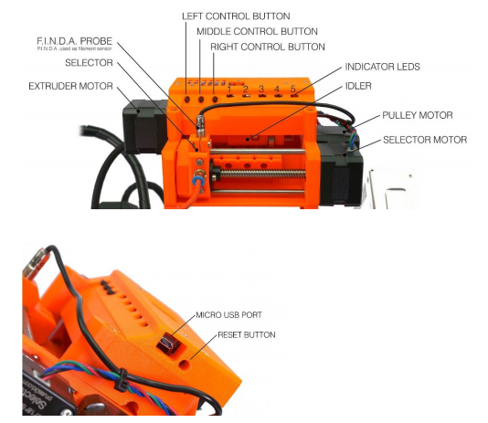

# 2. Quick guide:

Please note that these instructions are only a quick overview for users who already have 3D printing experience. We recommend reading the full description.

* Download and update the firmware from <https://github.com/bigtreetech.>
* Install the corresponding TMC Driver;
* Place the consumable shaft bracket behind the printer, and treat the end of the consumable to an acute angle, and pass the consumable through the MMU2DIP in order. It is recommended that the installation space be greater than 70×100CM

to avoid the consumable being entangled.

# 3. Update the firmware:

Visit https://github.com/bigtreetech to download and follow the new firmware;

Use USB to connect to your PC, start FlyMcu

1. Click EnumPort to search for the port,

2. In Port: select the correct printer port,

3. Then select the correct firmware and set it as shown below,

4. Click Start ISP to start the firmware update, and wait for the progress bar to reach 100% update completion.

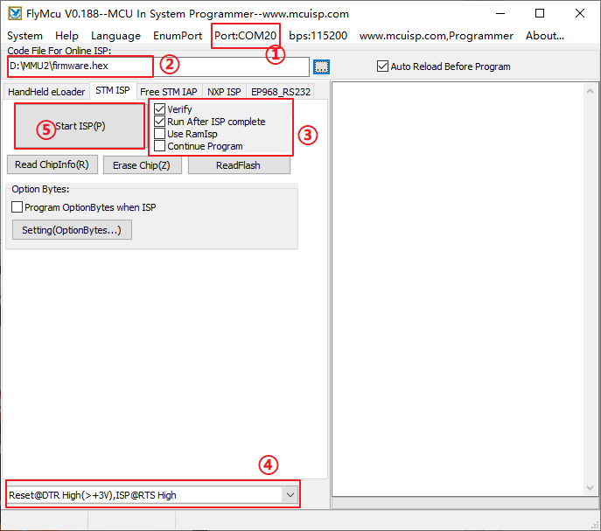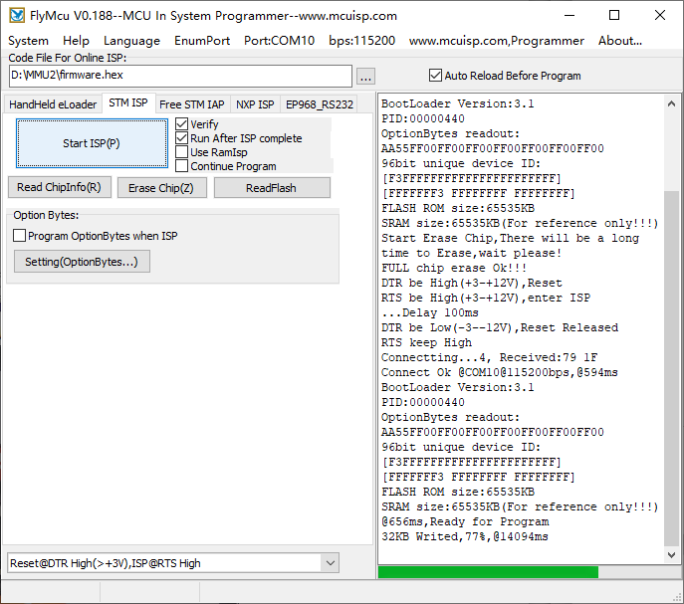

**4、Install drivers**

MMU2DIP supports SPI and UART firmware, and chooses to install different TMC drivers according to different firmware types.uses a shorting cap to connect the red frame in the figure. The subdivision and drive current are set by firmware.

**4.1 TMC Driver-UART Mode:(eg: TMC2208, TMC2209)**

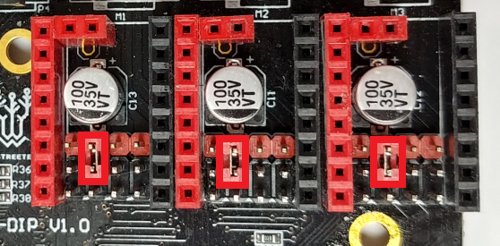

**4.2 TMC Driver-SPI Mode: (eg: TMC2130, TMC5160）**

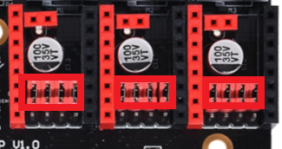

**5、Initialization process**

MMU2DIP and the printer are turned on at the same time. Initialization will not start the motor. The selector will not be moved until printing starts, and a collision sound may be heard (for about 10 seconds). Don't worry, this is part of the selector reset.

**6、Loading/Unloading/Selecting/Ejecting filament**

As shown in the picture, you must cut off the end of the consumable, the sharp end to ensure that the MMU2DIP unit is inserted correctly. At the same time, straighten the consumables as much as possible.

There is no need to preheat the nozzle, because the consumable is only pushed to the MMU2DIP unit, and the filament is inserted into the extruder automatically.

**6.1 Load 5 consumables**

1. Go to LCDMenu-Load filament-Load All.

2. The selector will move to the first position, the first LED will start blinking red.

3. Push the filament to the first PTFE tube until it's caught by the drive gear.

4. The filament will be pushed until it's detected by the FINDA, then it will be retracted from the selector, ready to be extruded when needed.

5. The LED indicator will turn green, signaling successful filament load, the selector will move to the 2nd position.

6. Repeat the process for the remaining 4 flaments.

**6.2 Loading one of the filaments using the LCD Menu**

1. Go to LCD Menu-Load filament-Load filament 1/2/3/4/5.

2. The selector will move to the first position, the corresponding LED will start blinking red.

3. Insert the filament into the correct PTFE tube and push it until it's caught by the drive gear.

4. The filament will be pushed until it's detected by the FINDA, then it will be retracted from the selector, ready to be extruded when needed.

5. The LED will turn green.

**6.3 Use the MMU control button to load one of the consumables**

1. Using the left and right control buttons, move the selector to the position corresponding with the filament number you'd like to load.

2. Insert the filament inside the white PTFE tube and continue pushing it until it's not possible to push it any further.

3. Press and hold the middle control button for a few seconds.

4. The corresponding LED indicator will start blinking red.

5. Push the filament a little bit further into the white PTFE tube until it's caught by the extruder.

6. The LED indicator should turn green after a short while, signaling successful filament load.

To unload filament simply pull the filament string from the white PTFE tube manually.

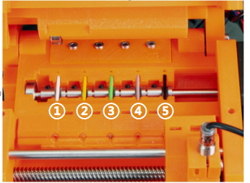

If you want to verify proper load of all five filaments before print, select LCD Menu-Loadfilament-Load all. The MMU2S unit should quickly try loading and unloading all 5 filaments one after another without any user interaction. After the last position, the LCD Menu should quickly try loading and unloading all 5 filaments one after another without any user interaction. Green LED should signal the success of load after each position.

**6.4 Ejecting filament**

Found in LCD Menu-Eject Filament-Eject Filament 1/2/3/4/5. It allows you to remove the last remaining piece of filament from the loading tubes after a filament spool is completely used up.

Ejecting during the print:

1. Pause print via the LCD menu.

2. Select the Eject filament option and choose which filament you want to remove.

3. Then, the selector moves to the side and the filament string is ejected forward

(through the MMU2S unit).

4. Remove the rest of filament string and press the knob.

5. Select the Load filament option and insert a new filament string as usual.

6. Resume the print process.

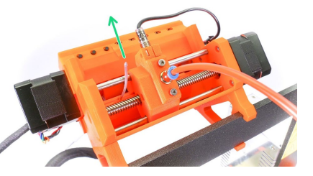

Please note that the ends of the filament string must be straight in order to perform the ejecting process correctly.

If the next filament slot is empty(filament string is not inside the MMU2DIP), the printer will ask you to insert filament. This is indicated by a red LED light above the empty filament slot.

Press the middle button on the unit and the filament will be loaded. If the operation is successful, thelLED changes to red-green flashing. Continue the print by pressing the right MMU2DIP button.

Please note that the nozzle has to be preheated in order to perform a filament ejection procedure, because the filament may still be in loaded in the printer's extruder.

**6.5 Load to the nozzle**

It is possible to load the filament not only to the MMU2DIP unit but also all the way to the printer's nozzle. This is useful when printing older G-codes on a printer with the MMU2DDIP unit attached. So if you have an existing G-code for single-material printing, you don't have to re-slice it using the MMU2DIP Single Mode profile. Just select option Load to the nozzle, select type of material, wait for the nozzle to preheat and select which filament you want to load. Then simply print the single-material sliced G-code.

**6.6 Unload filament**

If the filament is loaded to the nozzle you can unload filament using this function. If the nozzle is not preheated, the preheat menu will automatically appear. Select the filament type, wait until the nozzle is preheated and confirm the unload by pressing the LCD knob.

**6.7 F.l.N.D.A explained**

F.l.N.D.A is an older design P.l.N.D.A probe repurposed as a filament sensor. When the filament is pushed through the selector, it raises a stainless steel ball. Its movement is detected by the F.l.N.D.A. There is a small red LED light on the back of the probe. As soon as the filament is detected, the light turns off.

When the filament is removed, the stainless steel ball falls back down. Please note that the ball is pulled down by gravity, that means the filament sensor won't work if you for whatever reason turn the MMU2S unit upside down.

